PARTICIPATING SCHOOLS: Please copy this document onto your letterhead and replace highlighted
text with your school’s information.

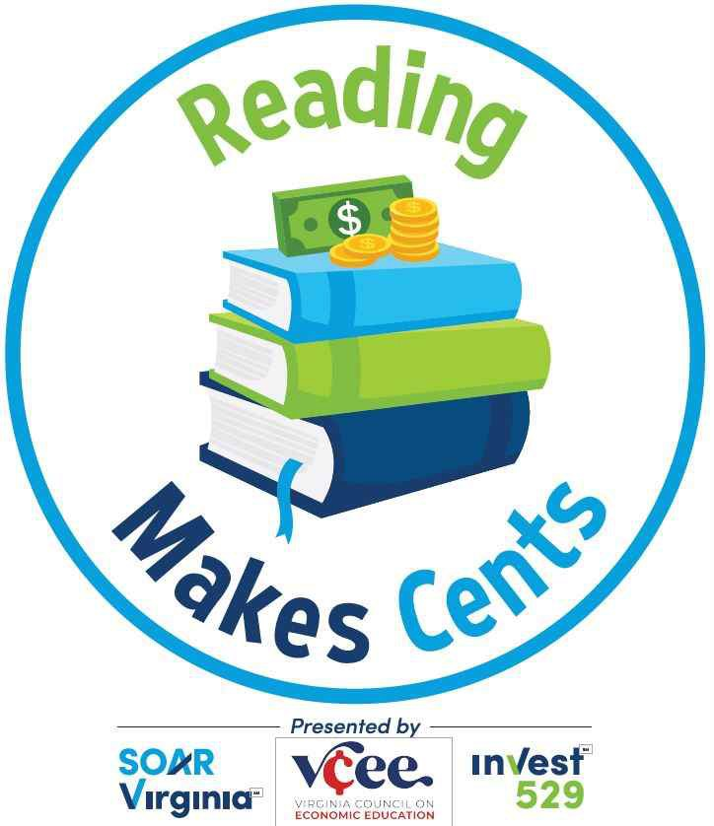
Dear Parent:

[SCHOOL NAME] is happy to be participating in Reading Makes Cents, a statewide reading program for children in kindergarten through eighth grade focusing on personal finance concepts.
Through this year’s selection of books, students will learn financial concepts such as the value of working to earn money, the importance of saving, the idea of prioritizing wants, and being good decision-makers. These are valuable life lessons that will benefit students as they grow up.
Our school also will earn 3 free books for our library, which I’m very excited to share with my students. Plus, if our school has the highest student participation rate within our region at the program’s close, we will earn an additional $500 worth of books. With your child’s participation, I know we can do it!

To participate: Encourage your child to read (or listen to or watch a video!) 5 books as explained on the attached Reading Challenge form. Full information and details are available at ReadingMakesCents.com.
Every child who submits a completed Reading Challenge form, certified by a parent or guardian, is entered into a drawing to win one of 14 Invest529SM savings accounts with an initial balance of $529, to grow year over year. (Entries are due May 16, 2025.)
As you know, education after high school is more important than ever before, whether it’s a degree from a 2 or 4-year college, an industry certification, or some other credential. As sponsors of the program, SOAR Virginia, Invest529 and the Virginia Council on Economic Education aim to help families start saving early for higher education expenses. Setting this expectation has been proven key to pursuing higher education.
Your signature on the Reading Challenge form is needed for Invest529 to contact you if your child is a
$529 savings account winner. Also, you may be provided additional information on saving for higher education but can opt out at any time. Your information will not be sold or used for any other purpose.

If you have any questions, please [SCHOOL CONTACT INFORMATION].
We’re thrilled to participate in this exciting program and pleased to offer your child the opportunity to
learn alongside us. I personally can’t wait to see your student involved, engaged and, most of all, reading!

Sincerely, [SIGNATURE]

